#### Mini School

UNDERGRADUATE PROJECT

Submitted in partial fulfillment of the requirements of

software development project 2 for the degree of

 B.Sc Engg. in CSE

#### By

*GROUP: Team Sparta*

#### UNDER SUPERVISION OF:

Sumi Khatun

Lecturer, Dept. of CSE

Bangladesh University of Business and Technology.

BANGLADESH UNIVERSITY OF BUSINESS

& TECHNOLOGY(BUBT)

##### Dhaka - 1216

##### March - 2021

#### Mini School

Group Members

Name ID

Md. Tanvir Rahman 18192103248

Julkar Nayem 18192103227

Md. Yeasin Arafat 18192103245



BANGLADESH UNIVERSITY OF BUSINESS

&

TECHNOLOGY

(BUBT)

DEPARTMENT OF COMPUTER SCIENCE &ENGINEERING

|  |
| --- |
| * Chapter - 1: Introduction * Chapter - 2: Implementations * Chapter – 3: Diagram * Chapter – 4: conclusion |

**Introduction**

This “Mini_School” apps is made for calculation school data and system. It mainly helps us to calculate class five, class eight, class ten and hsc batches students system and it also calculate teacher’s salary system, stuff salary and it also part with class by class data. It’s calculated students payment and it also manage students address parents name and phone number for message their result. It’s so useful things for school system because it’s result part add result on specific student and show a message. This project mainly based about 500 students. And one table have all student’s data and other table has class by class data and it also has a result table for update result and it also a teacher table for manage teachers system and classes. So, we all the team members think that it’s so many helpful for mini school system.

**Database ER-Diagram**

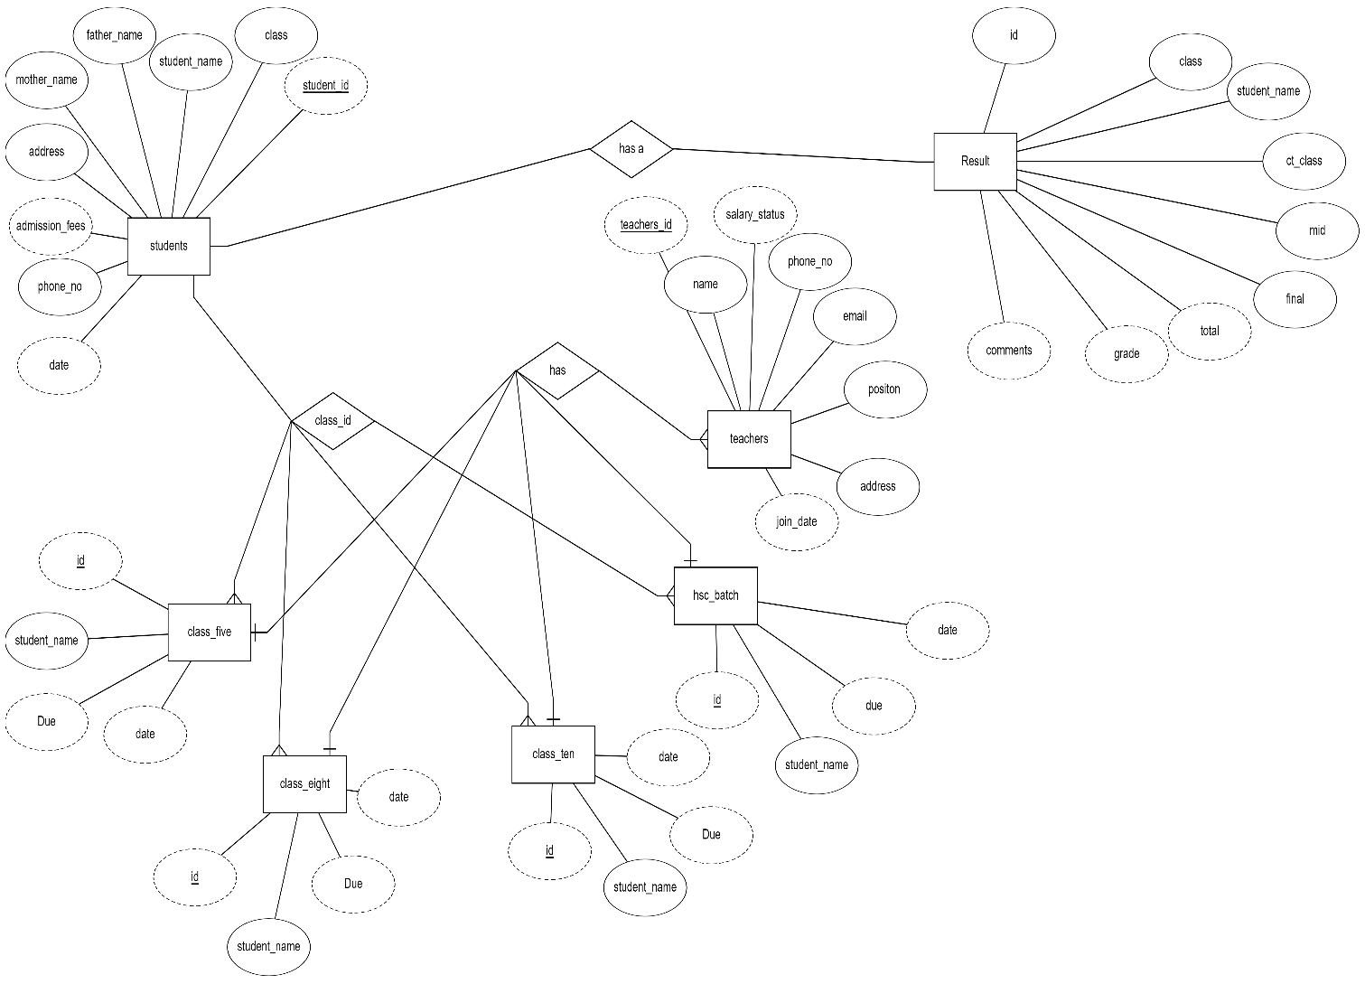

Picture 1: ER- Diagram

**Normalization**

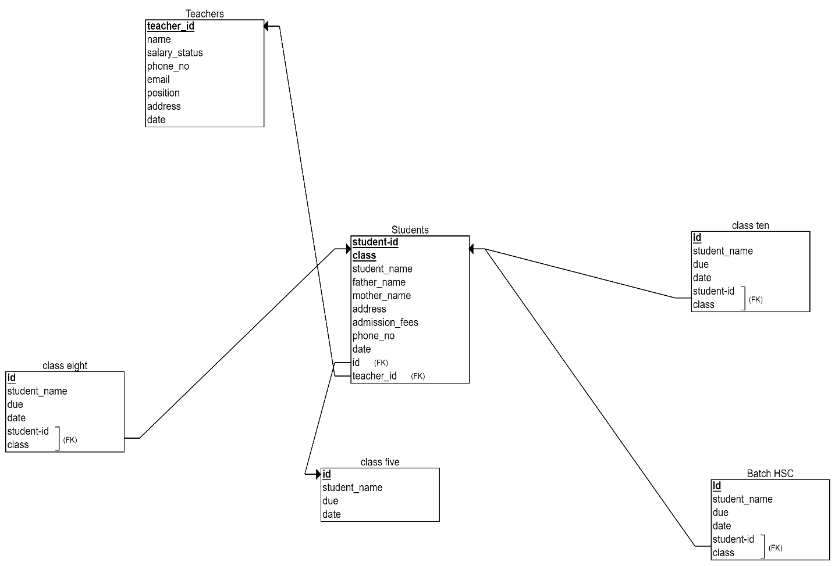

Picture 1: Normalization - Diagram

**Schema Diagram**

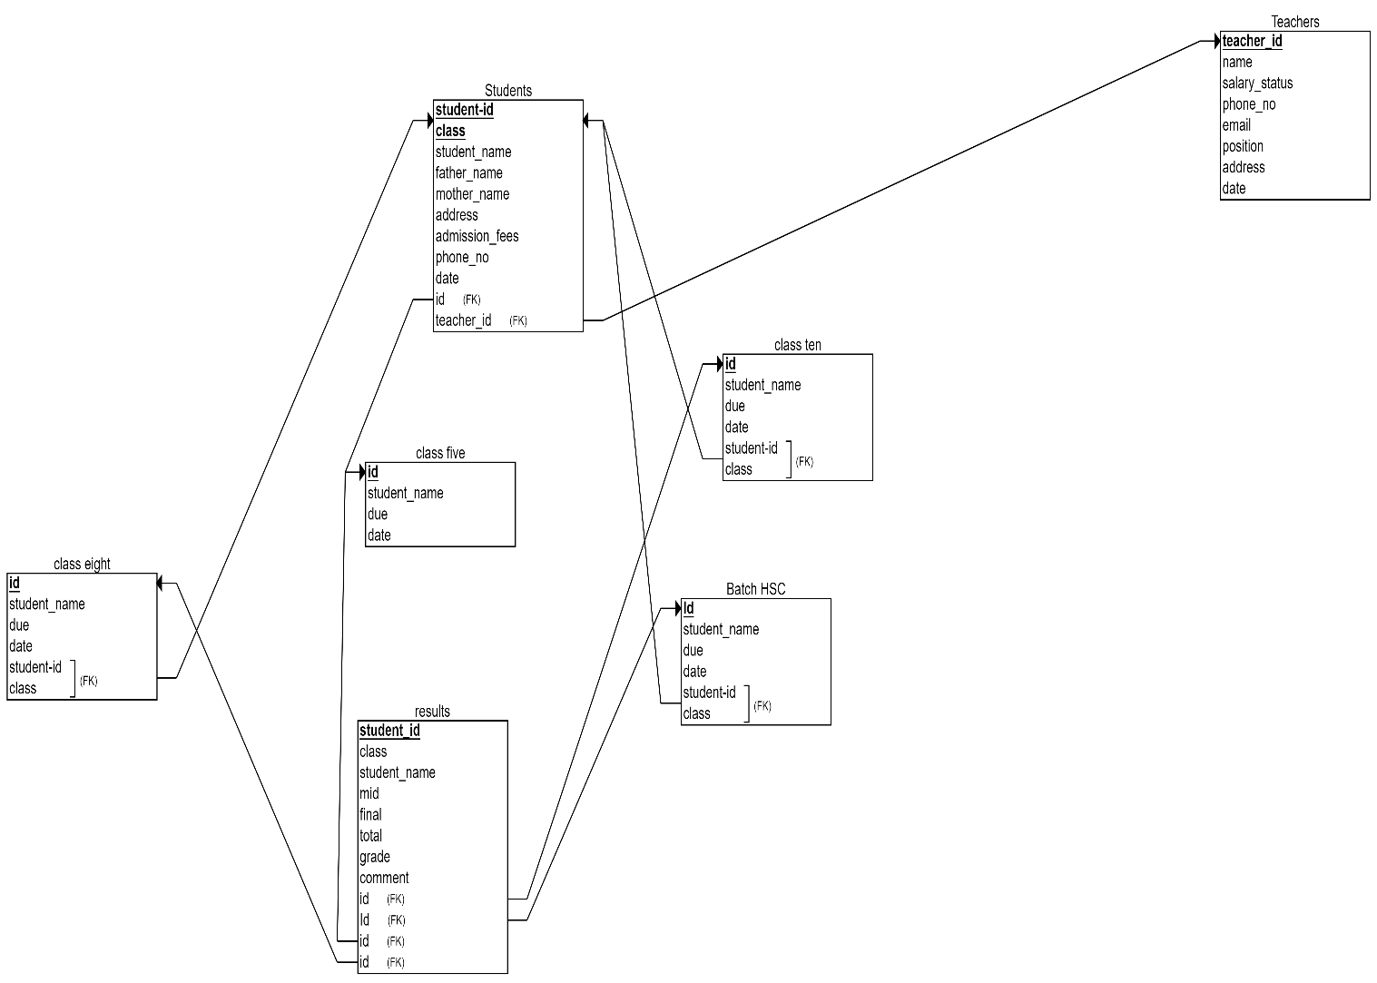

Picture 3: Schema Diagram

**Implementation**

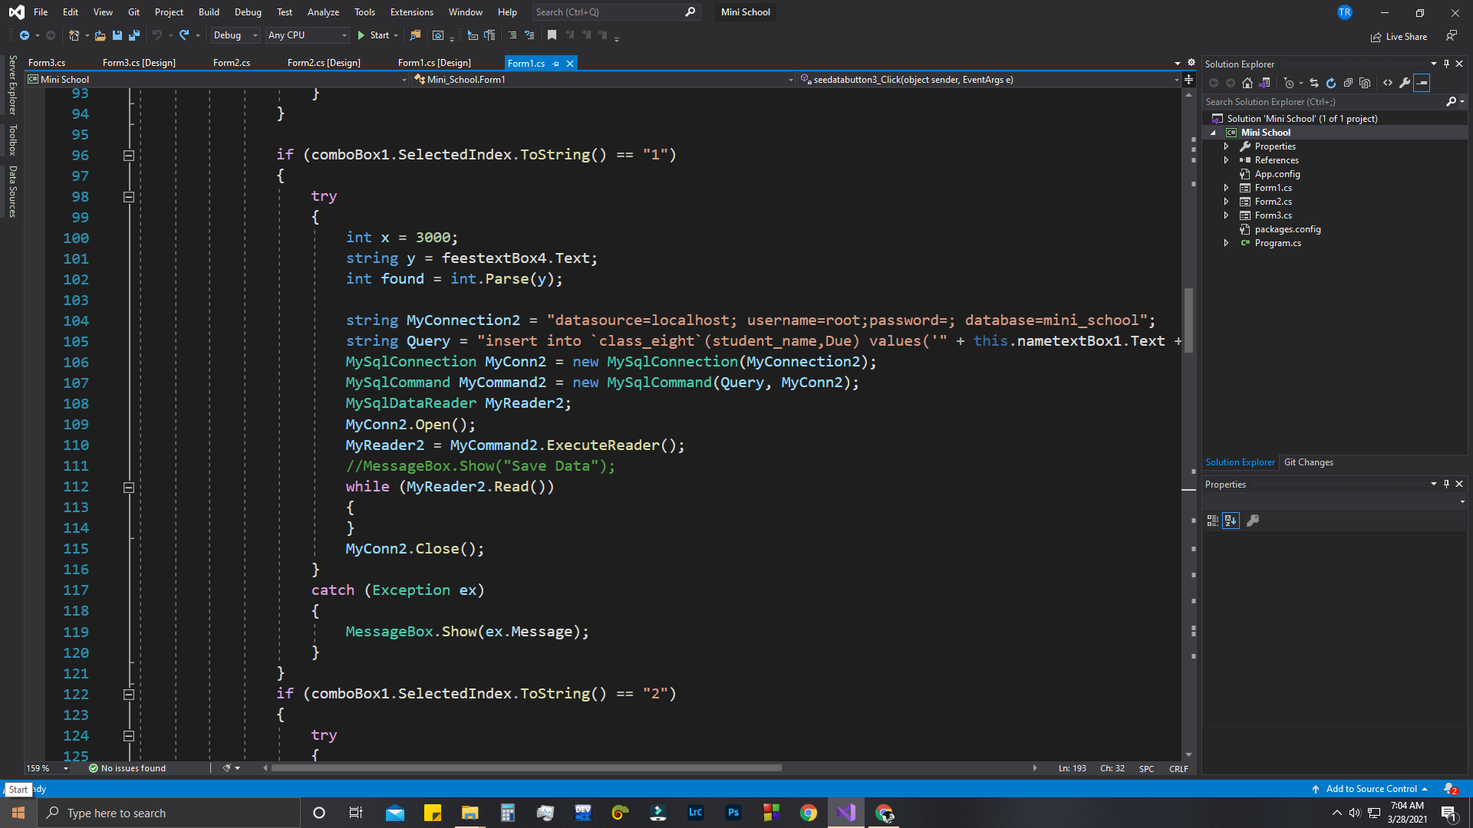

Picture 4: Input data students Table

This is the system of input data to students table for this apps and it also create some child table by the class, it also has ability to making class five table, class eight table, class ten table , HSC batch table.

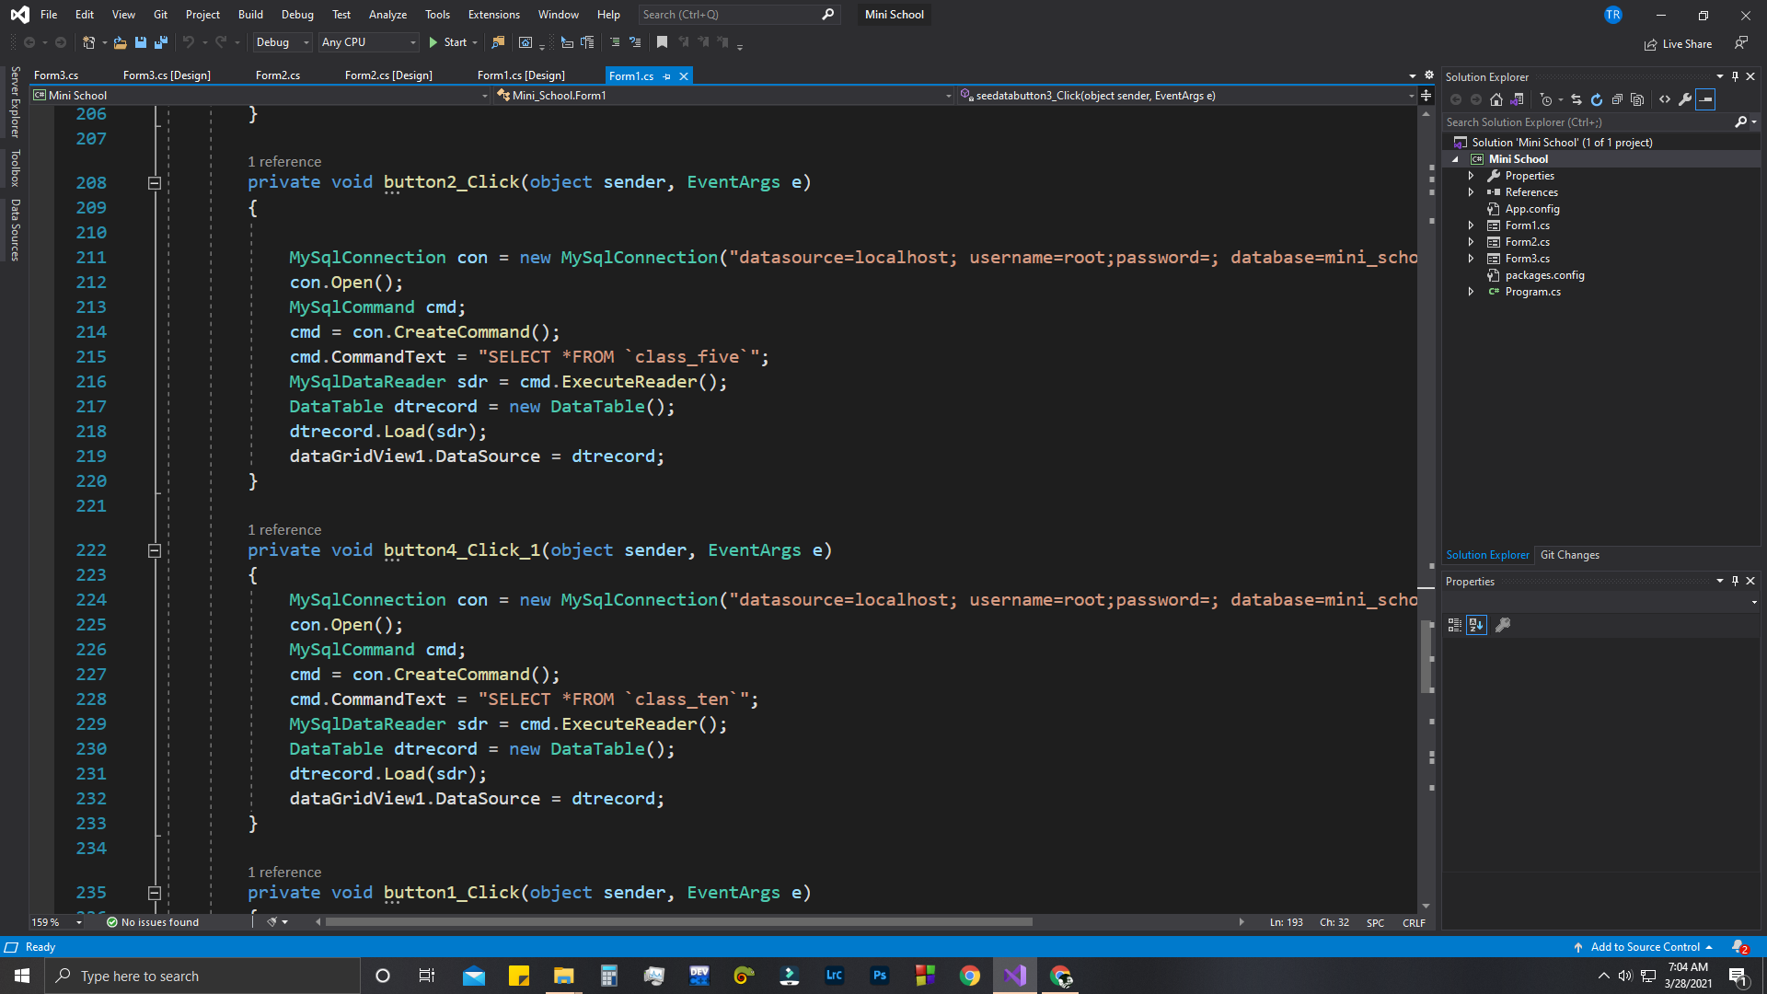

Picture 5 : Input Data Class table by students table



Picture 5 : Input Data Class table by students table

This table has creating by class and also by students table for this system a data come to class table by students table class. So it has a relationship with students by class.

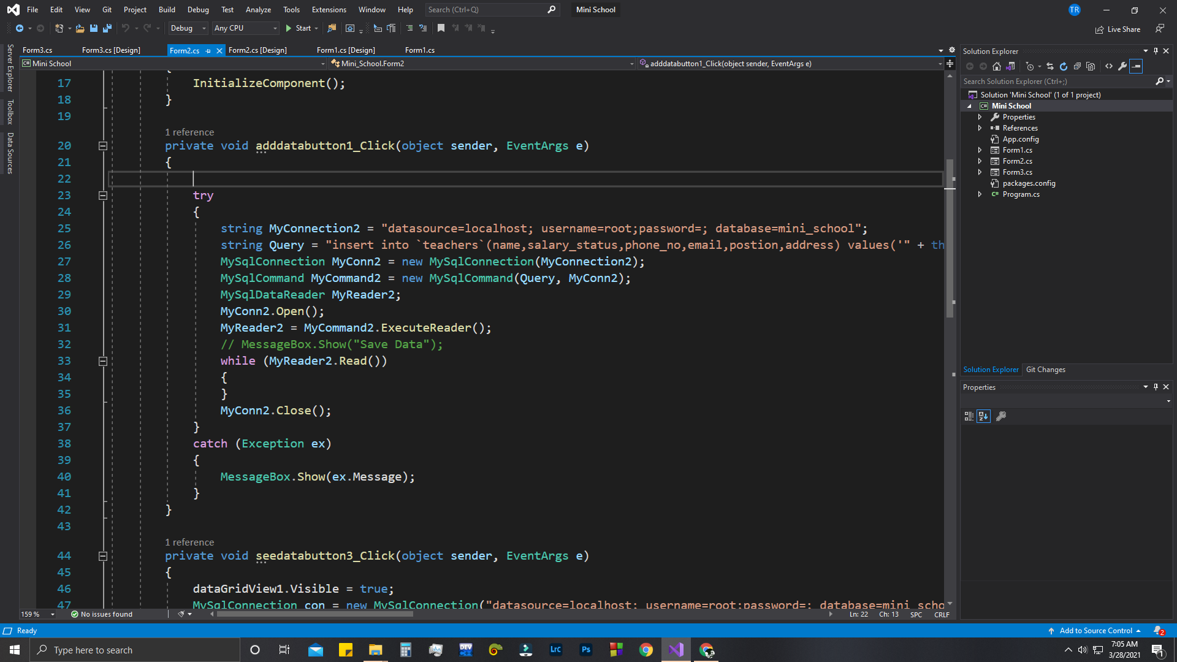

Picture 6: Add data to teacher’s table

This table is mainly based by add teachers is has salary system and teacher address and teachers’ class for connect to students class.

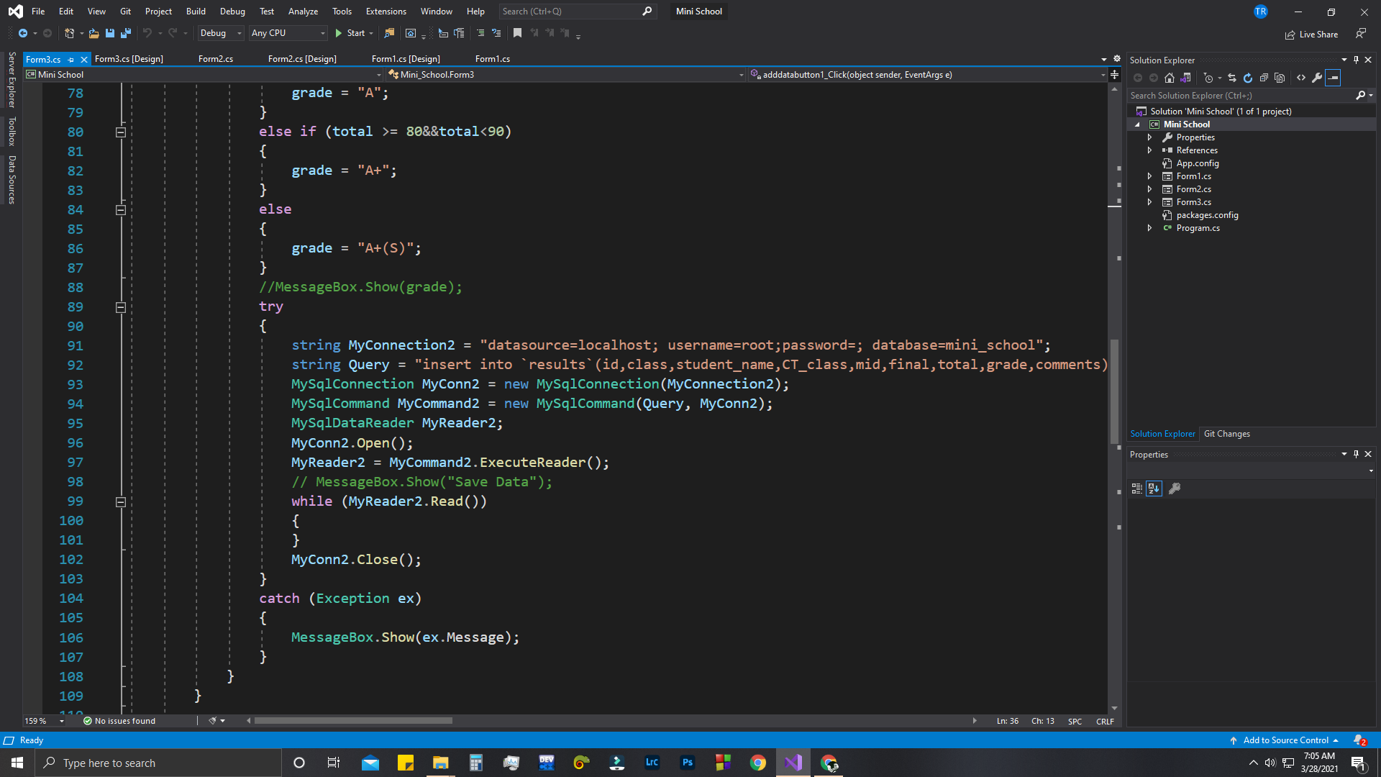

Picture 7: Input Result data by this code

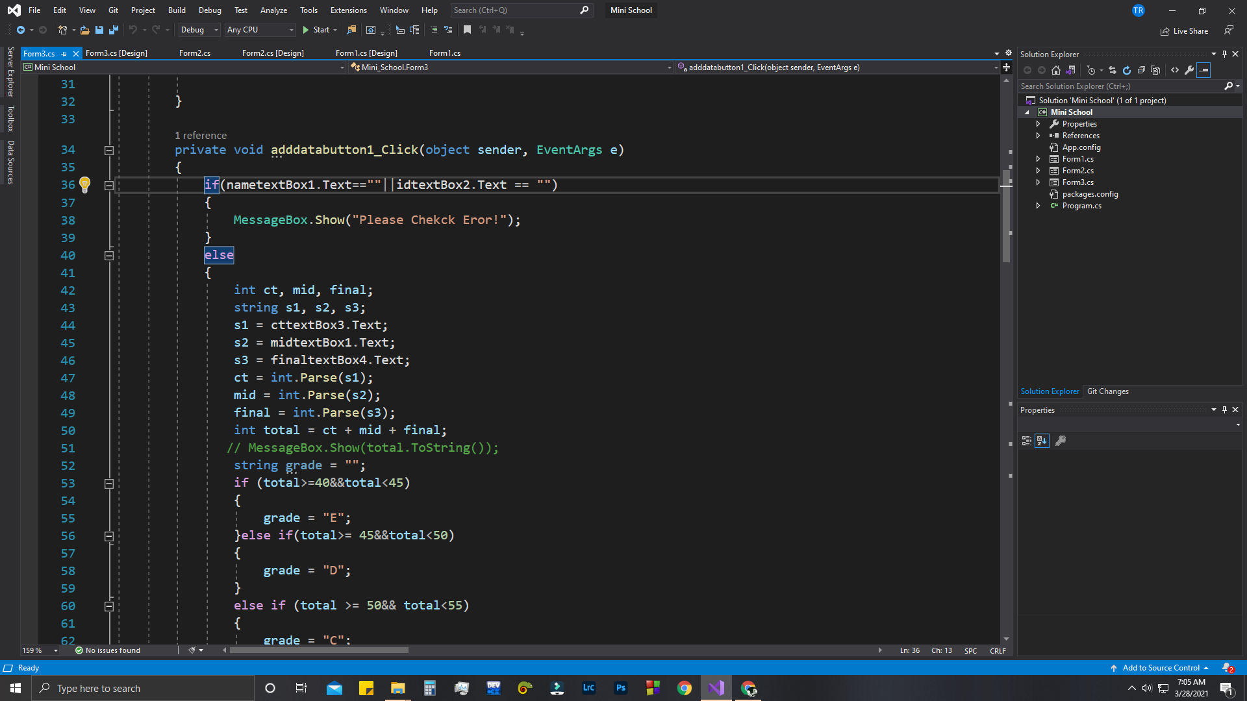

Picture 8 : Input Grader system Code

This table save result by students exam results. In here input student id that is a primary key. And then student test, mid and final semester results then it will show you grader and add data to result section.

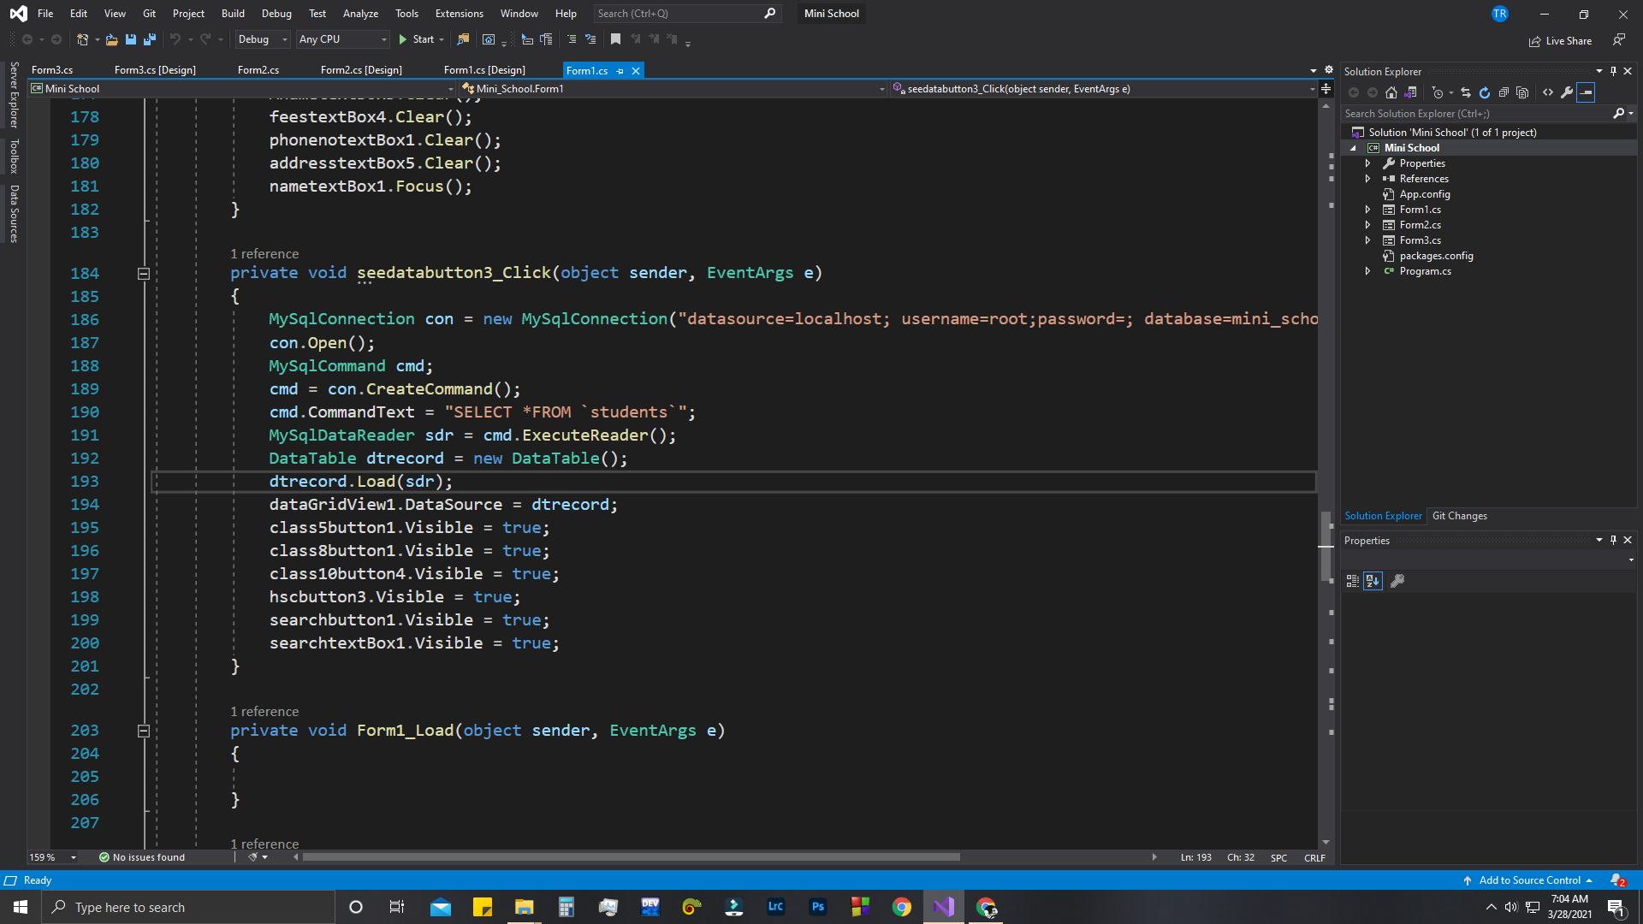

Picture 9: Data gird View show table code

I always use this code for show all the table in data gird view. In this process I show students, teachers, class five, class eight, class ten, hsc batch and result table data to a data gird view.

Just here I change select query for data gird view.

**Conclusion**

I use here local database that by XAMPP software. So that’s why I can’t able to add photo upload system for students and teachers table because it just able to upload 64kb image. It mainly helps us to calculate class five, class eight, class ten and hsc batches students system and it also calculate teacher’s salary system, stuff salary and it also part with class by class data. It’s calculated students’ payment and it also manage students address parents name and phone number for message their result. It’s so useful things for school system because it’s result part add result on specific student and show a message. This project mainly based about 500 students. And one table have all student’s data and other table has class by class data and it also has a result table for update result and it also a teacher table for manage teachers system and classes. So, we all the team members think that it’s so many helpful for mini school system. I make another project for software development course that’s is not suitable for database management course so I make another group and make another project for this database management course.